Maths Murder Mystery 1
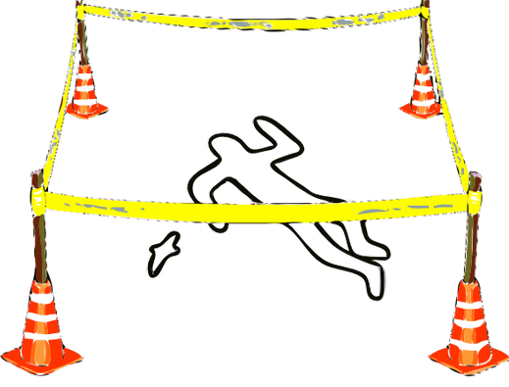

A murder has been committed in the maths department! A body has been discovered surrounded by mathematical objects and only the hardworking maths teachers were in school, doing long division sums for fun at the weekend. So one of them must be the murderer!
Your task, should you choose to accept it, is to find:
1) the murderer
2) the room
3) the murder weapon
Work quickly - who knows who could be next!

Possible murder suspects:
1) Shelby - who was wearing a white, T-shirt with 2 stripes and ripped jeans on the day of the murder.
2) Carmen - who was wearing a knee-length green skirt, white blouse and gold watch.
3) José Carlos - who was wearing a blue Adidas T-shirt with 3 stripes on the sleeves, Bermuda shorts and a baseball cap.
4) María del Mar - who was wearing a black and white pin-stripe suit with shiny black shoes.
5) Silvia - who was wearing a blue knitted jumper with a picture of pi on the front, and brown cords.
Possible rooms:
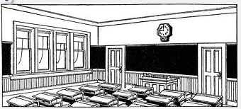
1) The Canteen
2) The Teacher’s Lounge
3) Room 20
4) Room 18
5) Room 17
6) Room 7

Possible murder weapons:
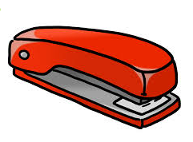
1) A wooden meter ruler
2) A large metal stapler
3) A dusty trundle wheel
4) A sharp compass
5) A large maths textbook
6) An oversized calculator

Clue number 1:
PDA NKKI PDA IQNZAN PKKG LHWYA EJ EO W JQIXAN.
Hint: 4 letter shift

Clue number 2:
Ht me ru ed er hr da ta po no ht ta ah sd rt pi se
Hint: Maybe letters could be swapped around somehow?

Clue number 3:
Tcejbolatematonsawnopaewredrumeht
Hint: Should you be reading this forwards or…?
Clue number 4:
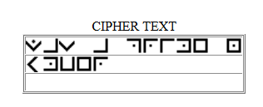
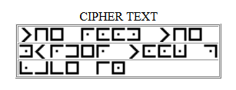
Clue number 5:
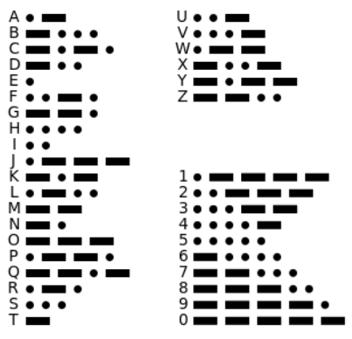
1 0000 0 010 0 00 000 01 1 0 1001 1 1000 111 111 101 11 00 000 000 00 10 110
Hint: 1 represents a dash, 0 represents a dot.

Clue number 6:
TRTURKCIURYPODUHOHRTPESMMPLNECIOEDOLIABAEESRKSMMEOANNENOCILY
Hint: Could splitting this into 4 lines of equal length help?

Clue number 7: 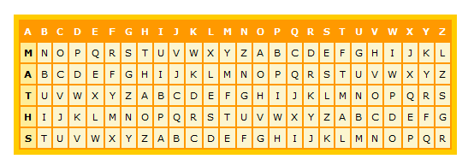

FHXTMDDXYWDWTZOQAKPFSTKVMEEKZ
Hint - Go along the M row and find F. What letter is above it on the top row? Now perhaps go to the second row.....
Look in the A row - find where the H is, what letter is above it in the top row?

Clue number 8:
ʇɥǝunɯqǝɹoɟsʇɹıdǝsouʇɥǝ ʇ sɥɹʇ ıs ɐuǝʌǝudɹıɯǝunɯqǝɹ
Hint: Do you have a mirror?

